**EXP NO 5: CREATE A SIMPLE CLOUD SOFTWARE APPLICATION FOR**

**LIBRARY BOOK RESERVATION SYSTEM FOR SIMATS LIBRARY USING**

**ANY CLOUD SERVICE PROVIDER TO DEMONSTRATE SAAS**

**DATE: 28-09-2025**

**AIM:**

To Create a simple cloud software application for Library book reservation system for

SIMATS library using any Cloud Service Provider to demonstrate SaaS

**PROCEDURE:**

**step1:** Go to zoho.com.

**step 2:** Log into the zoho.com.

**step 3:** Select one application step.

**step4:** Enter application name as library book reservation system.

**step 5:** Created new application as library book reservation system.

**step 6:** Select one form

**step 7:** The software has been created.

**IMPLEMENTATION:**

**Form 1: Al Book Details:**

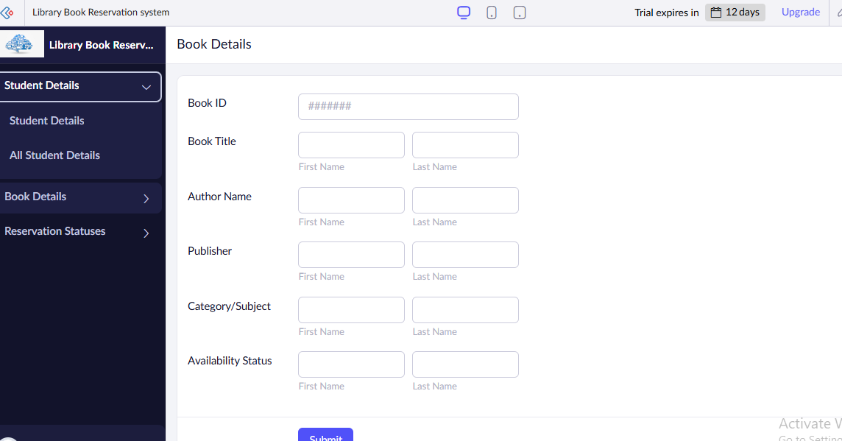

**Form 2: Reservation Status**

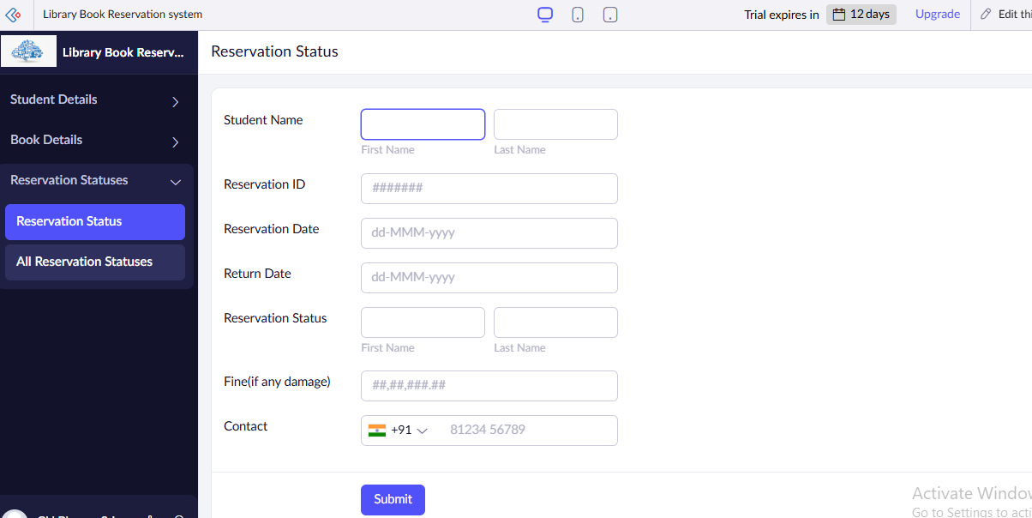

**Form 1: All Book Details**

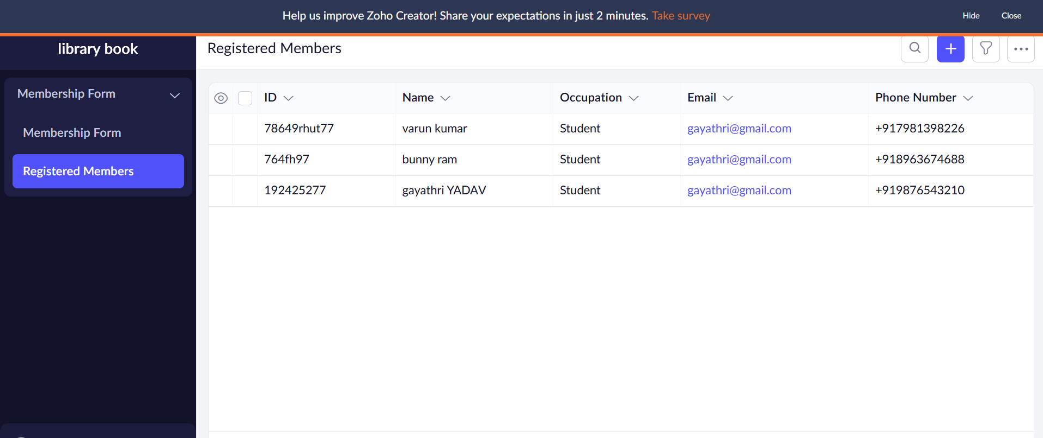

**Result:**

A cloud‑hosted SaaS web app where Chennai Library reservation System by locality, submit applications, pay online, and manage contracts — all via subscription accounts.